**Step 1: Login to production data stage server b01aciisd004 as root:**

**Step 2: Upload** *sds631_aix_ppc64_gskit.tar* **to the folder /tmp:**

**Step 3: Upgrade GSK to version** *8.0.14.26***:**

cd /tmp

tar xvf sds631_aix_ppc64_gskit.tar

cd sdsV6.3.1

cd ibm_gskit

# several files with the suffix rte can be seen

ls

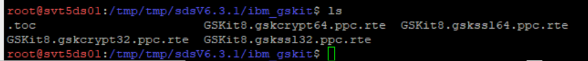

# simply press key “Enter” to go to next page when running **smitty**

smitty

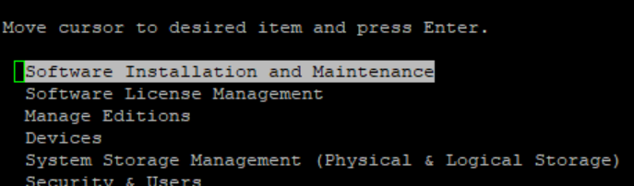

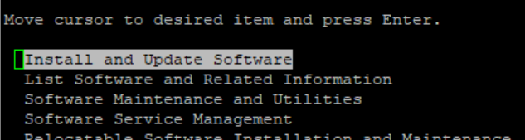

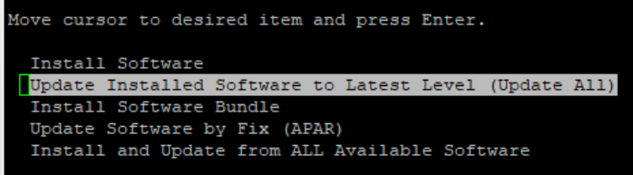

# enter location of GSK: ./

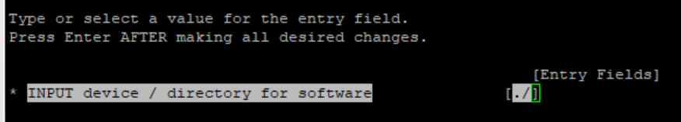

# scroll the page down to “ACCEPT new license agreements” and press key “Tab” to change value to “yes”

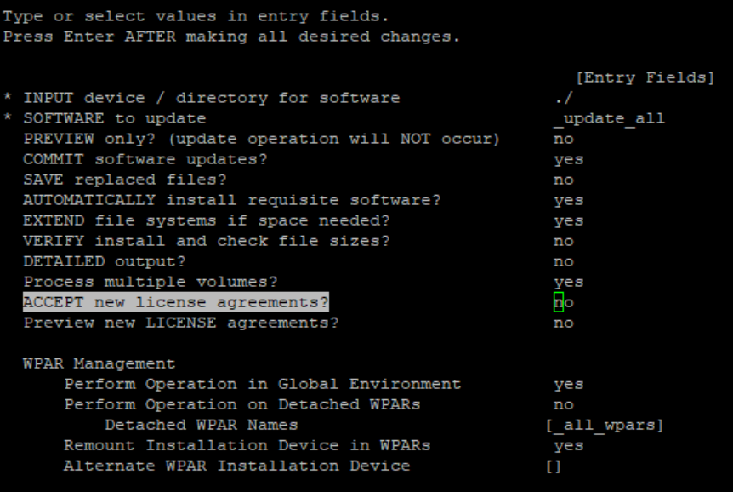

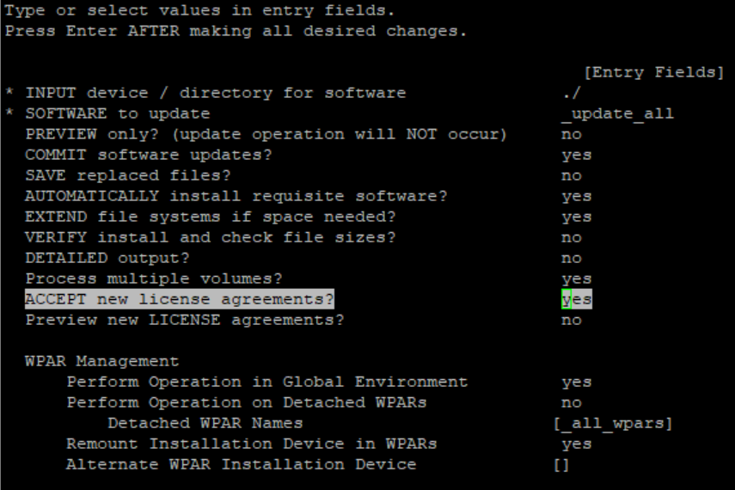

# press key “Enter”

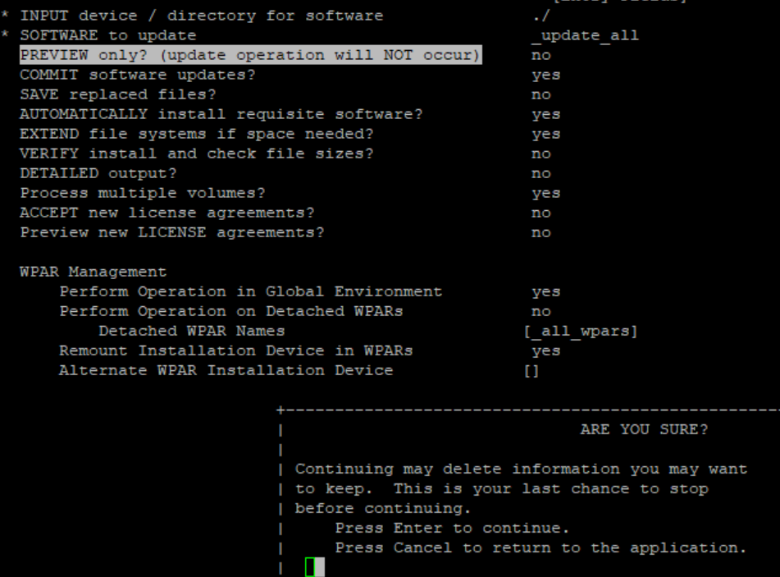

# press key “Enter” again

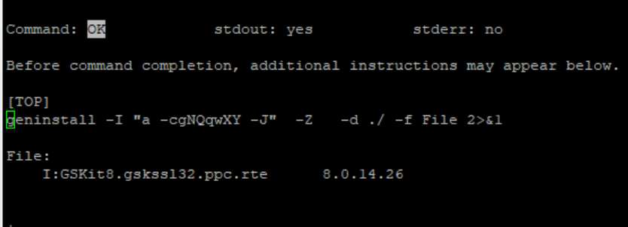

# enter combined keys: “Esc + 0” to exit smitty

lslpp -l | grep gsk

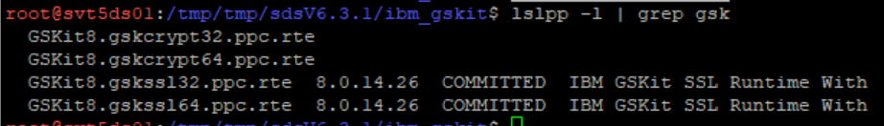

gsk8capicmd_64 -version

